|  |  |  |  |
| --- | --- | --- | --- |
|  | PRIYANKA BHARAT | | BUSINESS INTELLIGENCE |
| DATA WAREHOUSING |
| SOFTWARE DEVELOPMENT |
|  | +971527361555 | SYSTEM ANALYST | |
|  | [priyankaramlani@outlook.com](mailto:priyankaramlani@outlook.com) | PROJECT MANAGEMENT | |

**WORK**

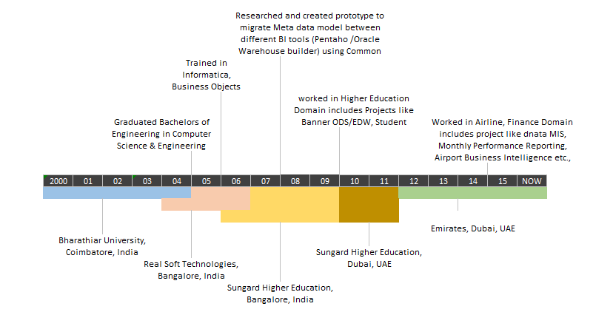

|  |  |
| --- | --- |
| **SKILLS SKILLS** | **TOOLS** |
|  |  |